# How To Enable Flash Player To Broadcast from The Chrome Web Browser

If you're using the Chrome web browser, or another web browser that no longer activates Flash by default, you might see a message saying "Flash player is not supported by your browser, you need flash installed to see Broadcast Videos":

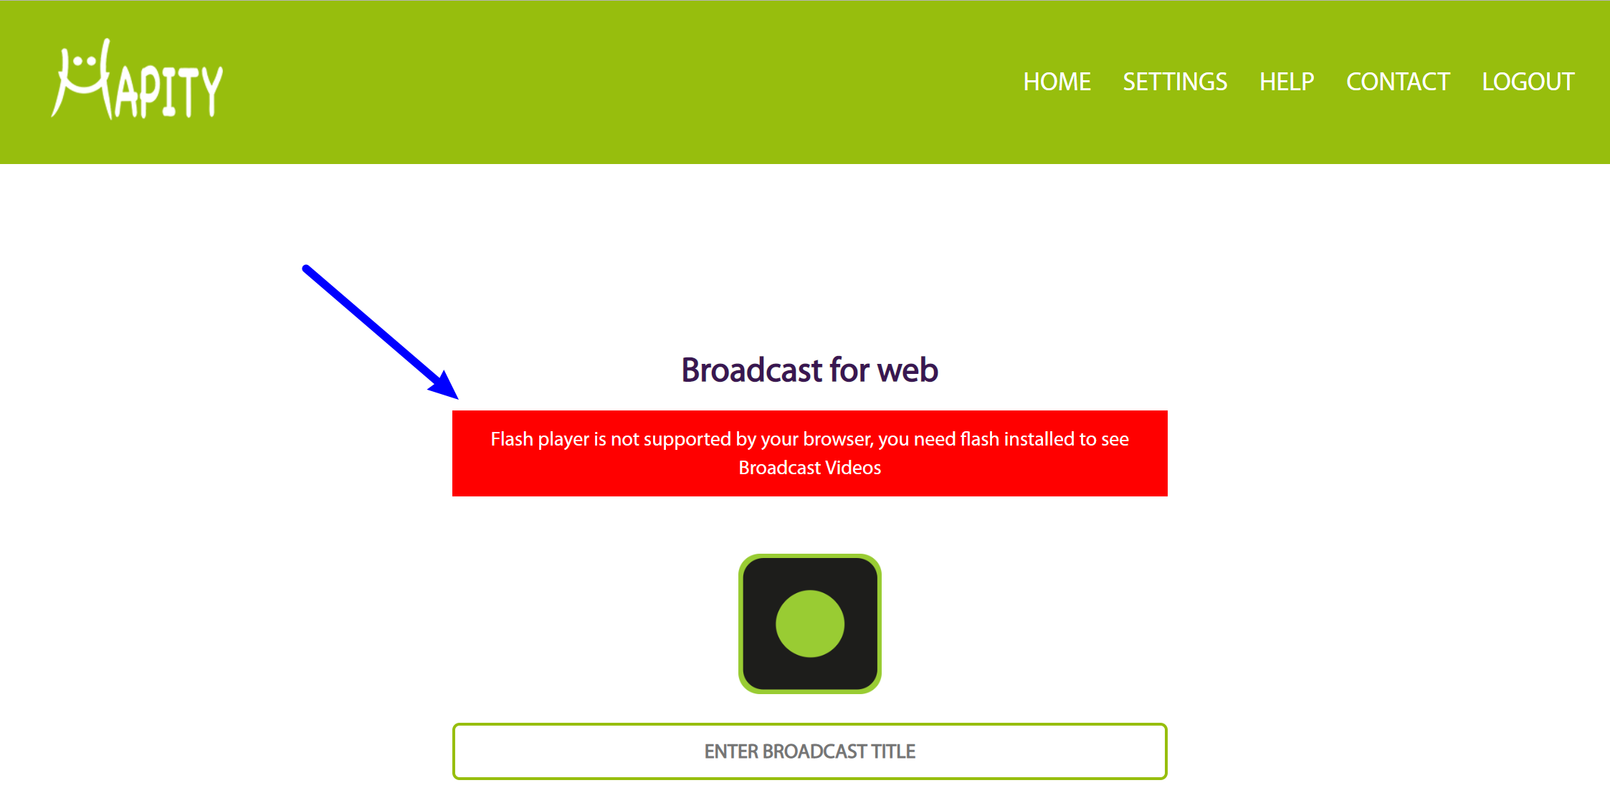

Flash-1

To fix that in Chrome, click on the green padlock next to the Hapity URL in your browser and select **Site Settings** from the drop-down:

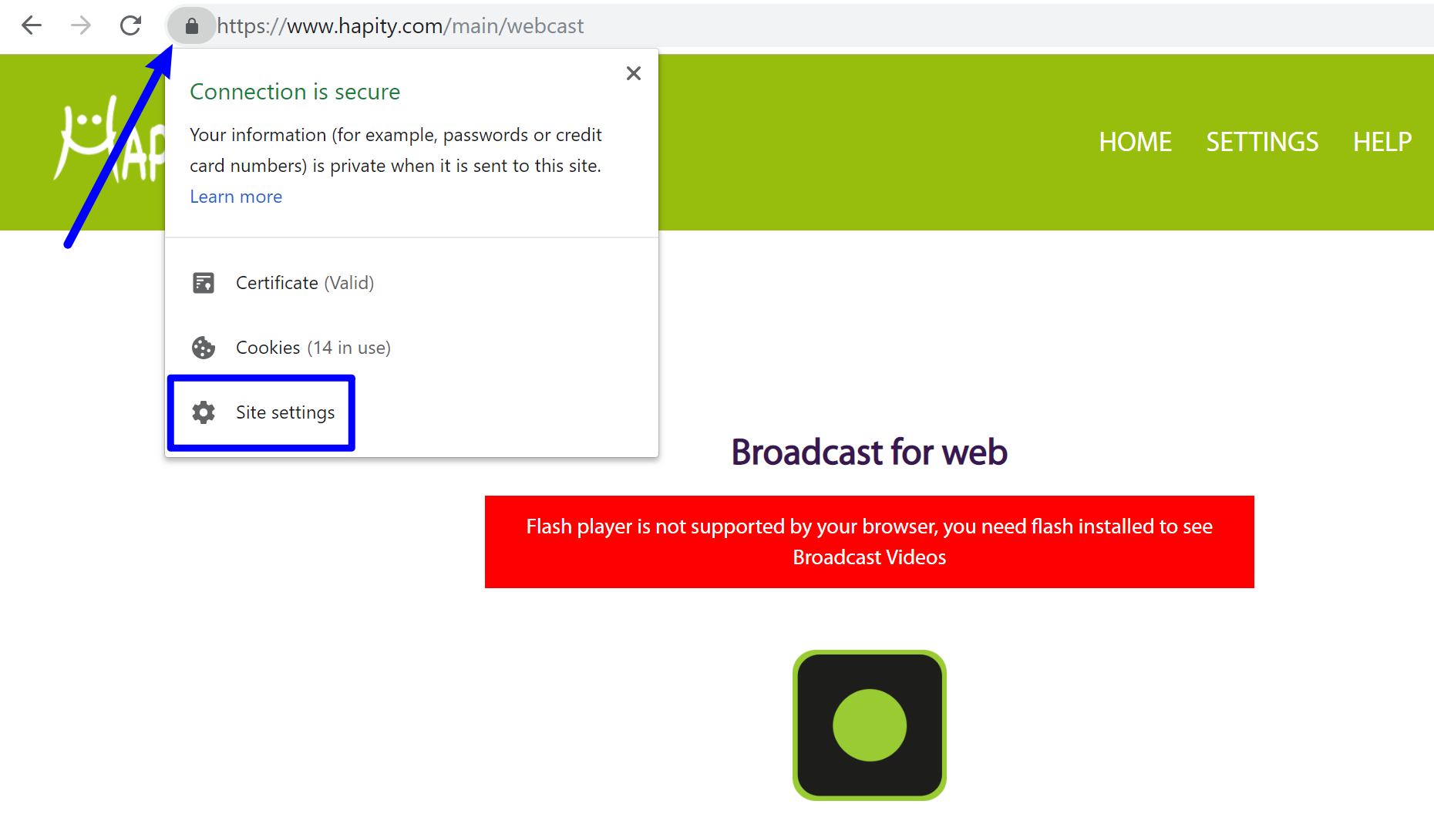

Flash-2

This will open a list of settings in a new tab. Find the option for **Flash** and choose **Allow** from the drop-down:

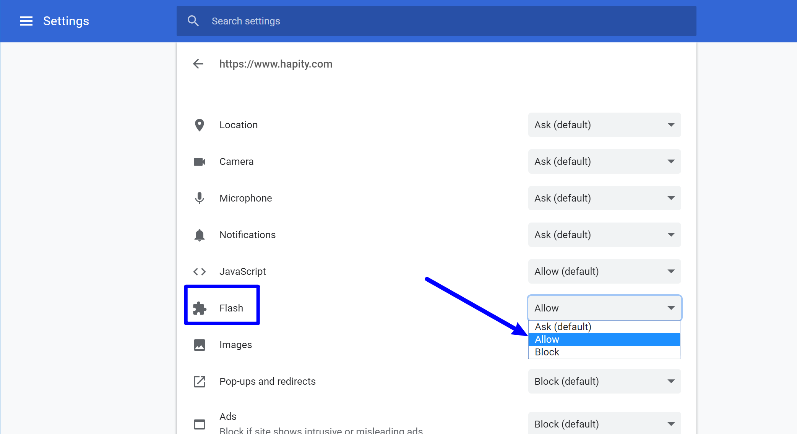

Flash-3

Then, after you reload the Hapity website, you should no longer see the error message.